What will we be learning?  - Exercise Physiology | Why this? Why now?  This unit is a compulsory for the A level course which will be examined through the H555/01 paper at the end of year 13. | Key Words:  Carbohydrate  Fibre  Protein  Fat  Minerals  Vitamins  Human growth hormone  Intermittent hypoxic training  Cooling aids  Erythropoietin  Anabolic steroids  Blood Doping  Glycaemic index  Creatine  Bicarbonate  Energy Expenditure  Preseason  Competition season  Post season
What will we learn? Year 1
2.1 Diet and nutrition and their effect on physical activity and performance
2.2 Preparation and training methods

Year 2
8.1 Injury and prevention and the rehabilitation of injury

What opportunities are there for wider study?
Optional Booster sessions
Careers/degree courses
- Sports science
- Physiotherapy
- PE teacher
- Sports analysis
How will I be assessed?
- Everlearner set assignments/check points
- Topic tests
- End of unit tests
- Mock Exams
A level – Exercise Physiology

What will we learn?  2.1 Diet and nutrition and their effect on physical activity and performance  - Diet and Nutrition  - Energy Expenditure  - Ergogenic aids  - Training methods | 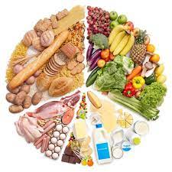  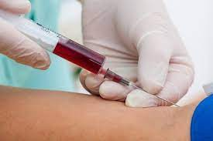
- Preparation and training methods  - Aerobic training  - Strength training  - Flexibility training  - Impact of training on lifestyle diseases | 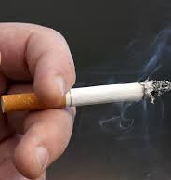
- Injury prevention and the rehabilitation of injury  - Types of injury  - Injury prevention  - Warm up and cool down  - Responding to injuries  - Rehabilitation of injury  - Treatment of common injuries | 